**Area of Study**: Along Route 302 from the Orange Center School to George St. area for scoping study. Arrows represent potential origins and destinations. The study will also explore improved geometry traffic calming options as vehicles approach the village.

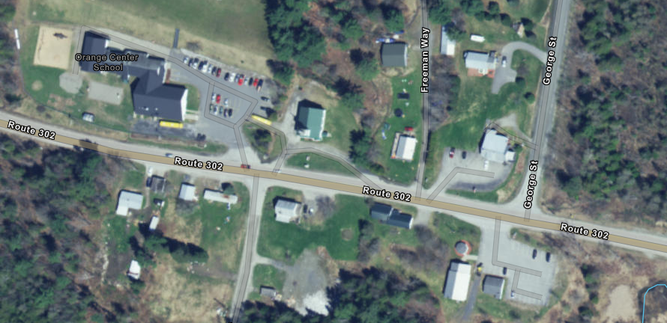

Orange Center School

Church

Orange Town Hall, Gazebo, Offices and Park& Ride

Orange village designation. With blue line representing one possible alignment for a sidewalk

